**C Companion**

A Python built toolbox to simplify and fasten C programming in any IDE and in any platform.

Tired of writing boring lines of code? Or if you are a newbie to the syntax of C Programming Language and facing difficulty to grasp it, this toolbox is the perfect solution. It lets you code faster by automating the boring stuffs like including headers, defining the main function as well as all the fundamentals from creating a variable to taking input and displaying output to the console. Robust syntax of the Decision making statements and the perfect recipe to cook your iteration statement is also included.

What makes it distinct is that it enables introduction to C programming to the school-aged children easily and using click and paste concept they can develop their basic programs and later manoeuvre through the contours of C.

**Getting Started**

**Simply Run ‘C Companion.py’**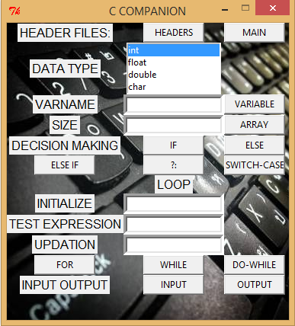

Screenshot of C Companion.

1. **HEADER FILES**
   1. *HEADERS:* Click to include all the commonly used header files in C.
   2. *Main:* Click to include the syntax of main() function.
2. **DATA TYPE**
   1. Select the data type from the list. (Select during variable or array type variable creation as well an during input/output and looping).
3. **VARNAME & SIZE**
   1. *VARIABLE*: Give the variable name and click.
   2. *ARRAY*: Give the size of the array and click.
4. **DECISION MAKING**
   1. *IF*: Click to include syntax of IF block.
   2. *ELSE*: Click to include syntax of ELSE block.
   3. *ELSE IF*: Click to include syntax of ELSE IF block.
   4. *?:* : Click to include syntax of ternary conditional operator.
   5. *SWITCH-CASE*: Click to include syntax of SWITCH-CASE block.
5. **LOOP**
   1. *Initialize*: give the integer value to initialize the loop variable.
   2. *Test Expression*: give the test expression excluding the associated variable name. (eg: ‘>10’ )
   3. *Updation*: give the updation excluding the associated variable name. (eg: ‘+2’,’-4’ )
   4. *FOR*: After entering the varname and the above parameter click to include appropriate FOR loop syntax.
   5. *WHILE*: After entering the varname and the above parameter click to include appropriate WHILE loop syntax.
   6. *DO WHILE*: After entering the varname and the above parameter click to include appropriate DO-WHILE loop syntax.
6. **INPUT OUTPUT:**
   1. *INPUT*: Select datatype,give varname and click to include syntax of appropriate scanf() function.
   2. *OUTPUT*: Select datatype,give varname and click to include syntax of appropriate printf() function.

**After clicking the required button simply paste the code in the IDE using CTRL+V.**

**Prerequisites**

$ pip install clipboard

$ pip install PIL

**Built With**

TKInter - [GuiProgramming](https://wiki.python.org/moin/GuiProgramming) toolkit for Python.

**Authors**

* **Rohan Dutta**.

**Acknowledgments**

* <https://www.tutorialspoint.com/python>
* <https://stackoverflow.com>
* <https://www.python.org>
* **Mr. Abhishek Bhattacharya**. (*H.O.D BCA,M.Sc(I.S) I.E.M*).